Folding rule
# Source: AI Source: Provided by: [Data Path: Persons Table -> ID Column: 1, Name_En Column: Motasem Essam] -> From: [ChatGPT] on [7/17/2026]
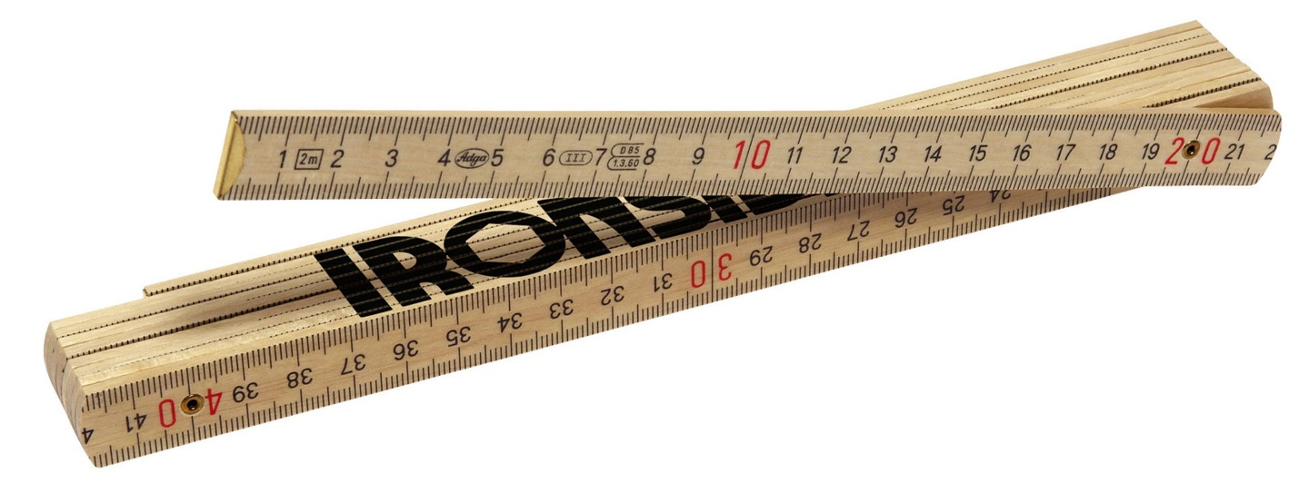
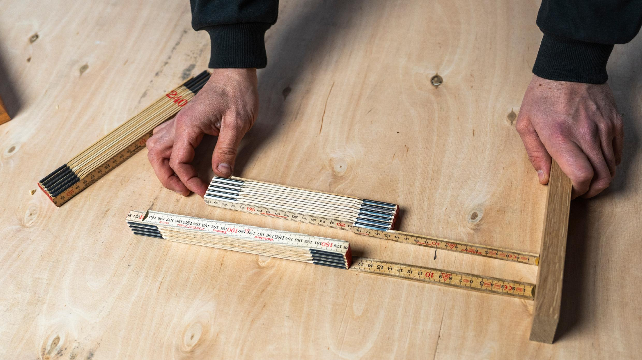
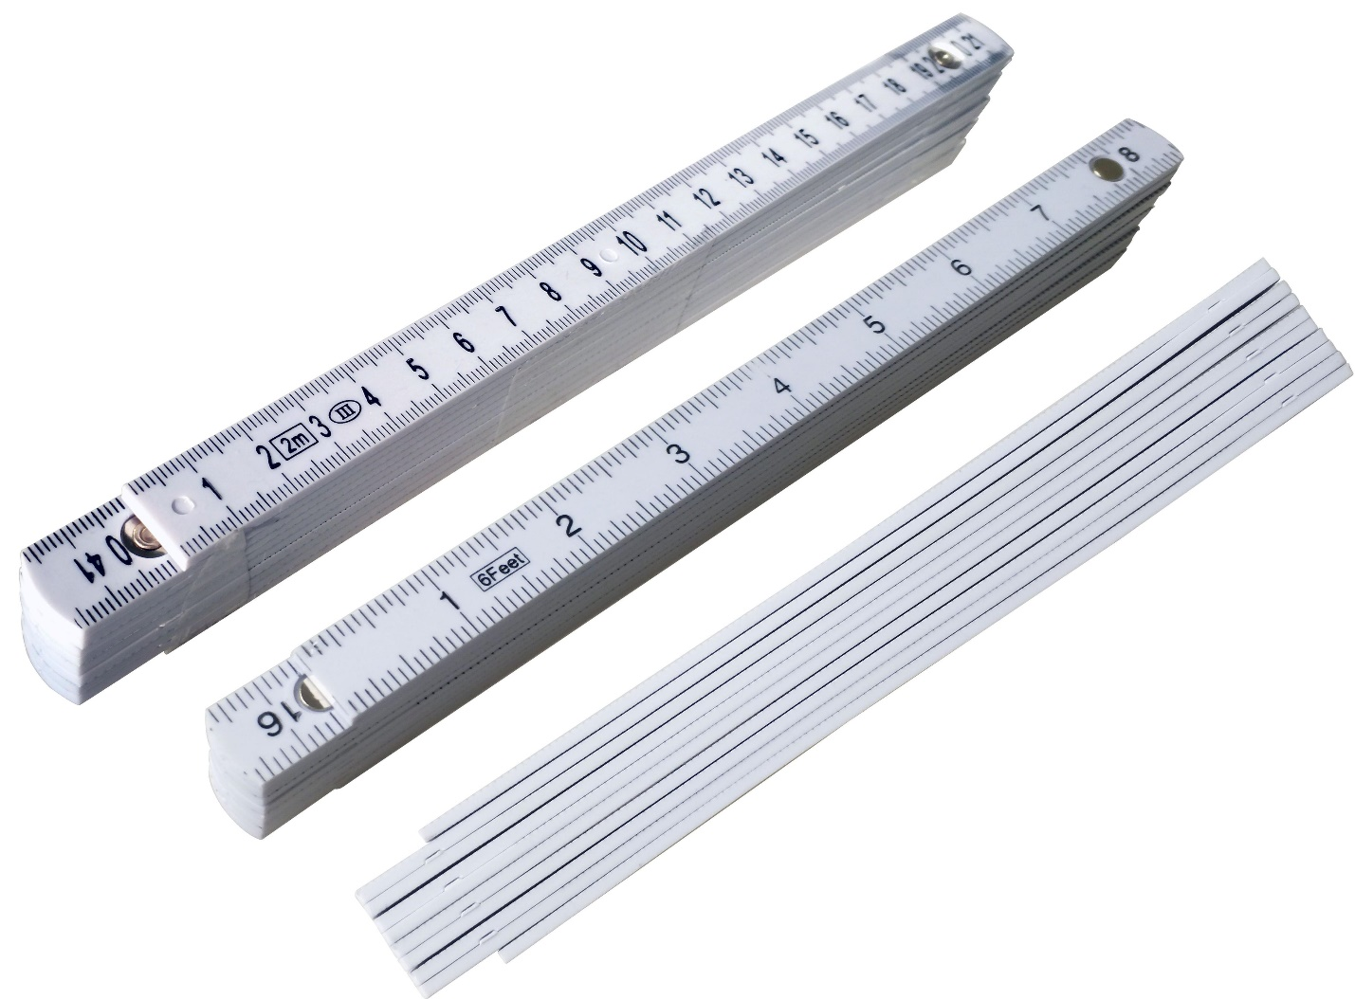
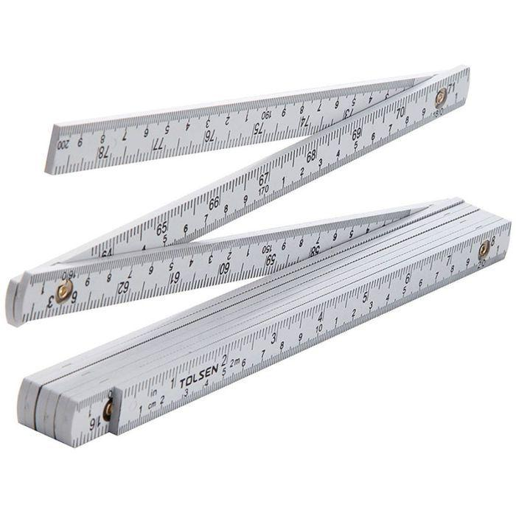
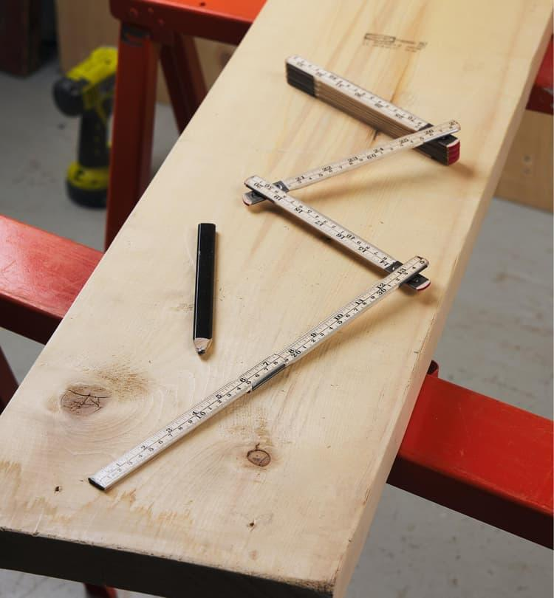
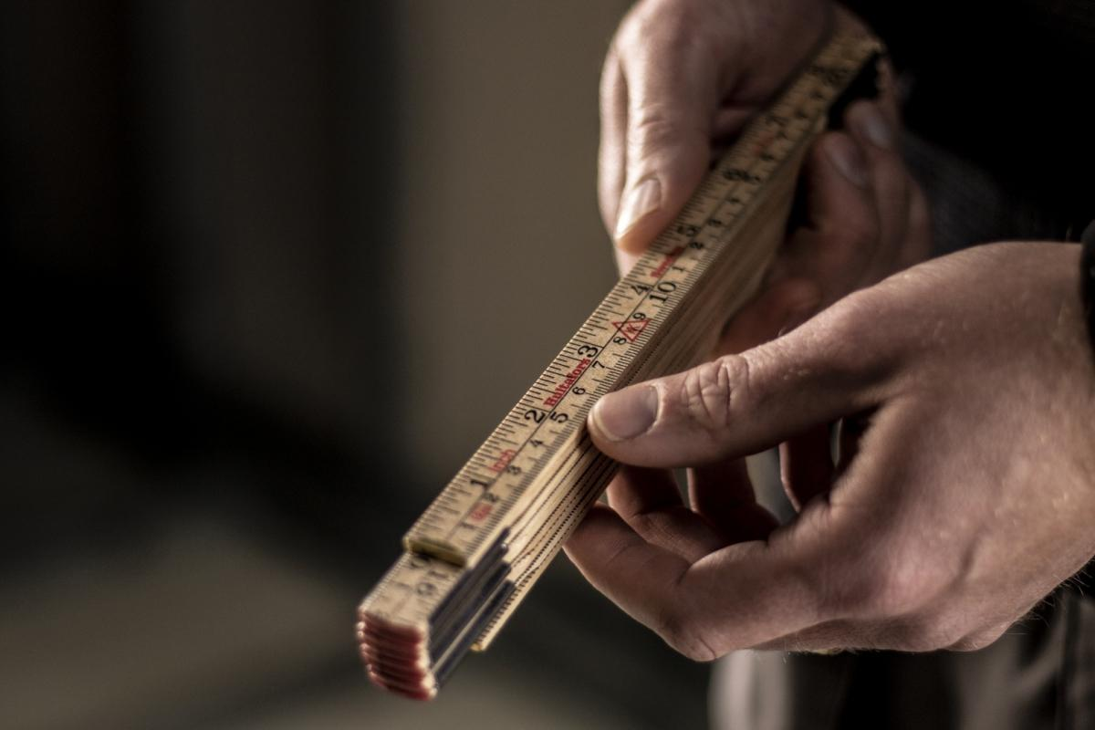
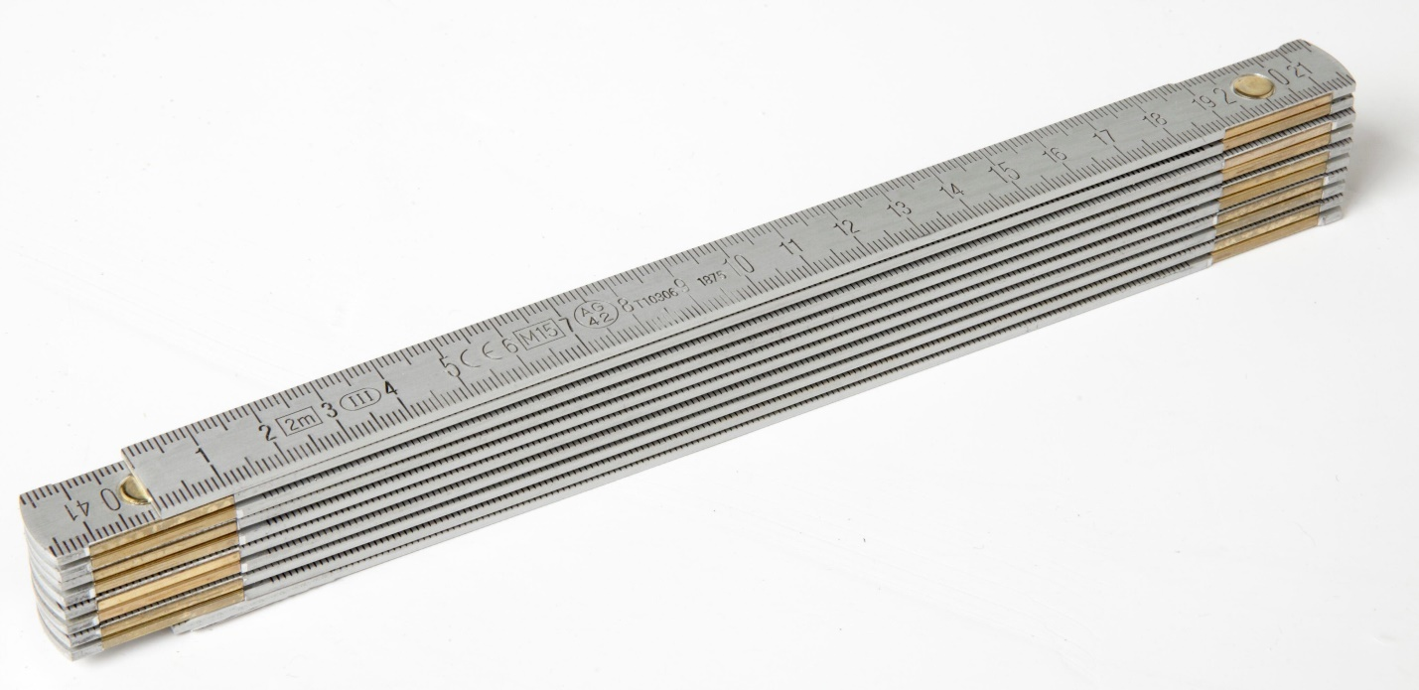
A Folding Rule (also called a Folding Ruler or Carpenter's Rule) is a rigid measuring instrument made of several hinged sections that fold together for easy storage and portability. When fully opened, it functions like a straight measuring rule and is commonly used in construction, carpentry, engineering, woodworking, and architecture.
Unlike a measuring tape, a folding rule remains rigid during use, making it particularly useful for measuring straight distances and transferring dimensions.

Definition
# Source: AI Source: Provided by: [Data Path: Persons Table -> ID Column: 1, Name_En Column: Motasem Essam] -> From: [ChatGPT] on [7/17/2026]
A Folding Rule is a rigid measuring instrument composed of hinged sections that fold for compact storage and unfold into a straight rule for measuring linear dimensions.

Purpose
# Source: AI Source: Provided by: [Data Path: Persons Table -> ID Column: 1, Name_En Column: Motasem Essam] -> From: [ChatGPT] on [7/17/2026]
A Folding Rule is used to:
- Measure length.
- Measure width.
- Measure height.
- Measure furniture dimensions.
- Measure building components.
- Transfer measurements.
- Draw straight reference lines.
- Perform layout work.

Construction
# Source: AI Source: Provided by: [Data Path: Persons Table -> ID Column: 1, Name_En Column: Motasem Essam] -> From: [ChatGPT] on [7/17/2026]
A typical folding rule consists of:
- Multiple hinged sections
- Graduated measurement scales
- Pivot joints
- Zero reference mark
- Straight measuring edge
Most folding rules have 8 to 10 hinged sections, allowing them to fold into a compact size.

Common Materials
# Source: AI Source: Provided by: [Data Path: Persons Table -> ID Column: 1, Name_En Column: Motasem Essam] -> From: [ChatGPT] on [7/17/2026]
Folding rules are commonly made from:
- Wood (traditional carpenter's rule)
- Plastic
- Fiberglass
- Aluminum
- Composite materials

Measurement Units
# Source: AI Source: Provided by: [Data Path: Persons Table -> ID Column: 1, Name_En Column: Motasem Essam] -> From: [ChatGPT] on [7/17/2026]
Most folding rules use the Metric System, the Imperial System, or both.
Metric Scale
- Millimeters (mm)
- Centimeters (cm)
- Meters (m)
Imperial Scale
- Inches (in)
- Feet (ft)

Common Lengths
# Source: AI Source: Provided by: [Data Path: Persons Table -> ID Column: 1, Name_En Column: Motasem Essam] -> From: [ChatGPT] on [7/17/2026]
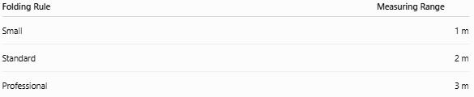
Folding Rule | Measuring Range
Small | 1 m
Standard | 2 m
Professional | 3 m
The 2-meter folding rule is the most common.

Least Count (Resolution)
# Source: AI Source: Provided by: [Data Path: Persons Table -> ID Column: 1, Name_En Column: Motasem Essam] -> From: [ChatGPT] on [7/17/2026]
The least count is the smallest graduation that can be read.
Typical values:
Type | Least Count
Standard Folding Rule | 1 mm

How to Measure with a Folding Rule
# Source: AI Source: Provided by: [Data Path: Persons Table -> ID Column: 1, Name_En Column: Motasem Essam] -> From: [ChatGPT] on [7/17/2026]
- Fully unfold the required sections.
- Ensure the joints are straight and locked.
- Align the zero mark with the starting point.
- Keep the rule straight against the object.
- Read the graduation at the end point.
- Record the measurement with the correct unit.

Example
Suppose an object ends at the 1.42 m mark.
The measured length is:
- 1.42 m
- 142 cm
- 1420 mm

Accuracy
# Source: AI Source: Provided by: [Data Path: Persons Table -> ID Column: 1, Name_En Column: Motasem Essam] -> From: [ChatGPT] on [7/17/2026]
A quality folding rule typically provides measurements accurate to approximately ±1 mm, depending on:
- Joint condition
- Manufacturing quality
- Reading technique
- Proper unfolding

Sources of Error
# Source: AI Source: Provided by: [Data Path: Persons Table -> ID Column: 1, Name_En Column: Motasem Essam] -> From: [ChatGPT] on [7/17/2026]
Instrument Errors
- Loose hinge joints
- Worn graduations
- Damaged sections
- Warped material

Observation Errors
- Parallax error
- Reading the wrong graduation
- Incorrect estimation

Positioning Errors
- Rule not fully extended
- Bent joints
- Misaligned zero mark

Environmental Errors
- Thermal expansion (metal rules)
- Moisture affecting wooden rules
- Dirt between sections

Applications
# Source: AI Source: Provided by: [Data Path: Persons Table -> ID Column: 1, Name_En Column: Motasem Essam] -> From: [ChatGPT] on [7/17/2026]
Folding rules are commonly used in:
- Carpentry
- Construction
- Architecture
- Civil engineering
- Woodworking
- Cabinet making
- Furniture manufacturing
- Interior installation
- Education

Advantages
# Source: AI Source: Provided by: [Data Path: Persons Table -> ID Column: 1, Name_En Column: Motasem Essam] -> From: [ChatGPT] on [7/17/2026]
A Folding Rule:
- Is rigid and stable.
- Measures straight distances accurately.
- Folds into a compact size.
- Requires no power.
- Is durable.
- Is easy to transport.
- Provides better stability than a flexible measuring tape.

Limitations
# Source: AI Source: Provided by: [Data Path: Persons Table -> ID Column: 1, Name_En Column: Motasem Essam] -> From: [ChatGPT] on [7/17/2026]
A Folding Rule:
- Cannot easily measure curved surfaces.
- Is less convenient for very long distances.
- Hinges may loosen over time.
- Is less precise than Vernier calipers or micrometers.

Comparison with Other Length Measuring Instruments
# Source: AI Source: Provided by: [Data Path: Persons Table -> ID Column: 1, Name_En Column: Motasem Essam] -> From: [ChatGPT] on [7/17/2026]
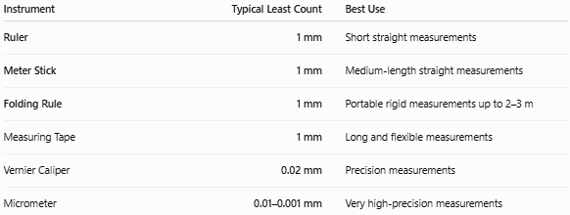
Instrument | Typical Least Count | Best Use
Ruler | 1 mm | Short straight measurements
Meter Stick | 1 mm | Medium-length straight measurements
Folding Rule | 1 mm | Portable rigid measurements up to 2–3 m
Measuring Tape | 1 mm | Long and flexible measurements
Vernier Caliper | 0.02 mm | Precision measurements
Micrometer | 0.01–0.001 mm | Very high-precision measurements

Care and Maintenance
# Source: AI Source: Provided by: [Data Path: Persons Table -> ID Column: 1, Name_En Column: Motasem Essam] -> From: [ChatGPT] on [7/17/2026]
To maintain accuracy:
- Keep the hinges clean.
- Avoid forcing the joints.
- Store the rule folded.
- Protect the graduations from wear.
- Replace damaged or warped sections.

Common Mistakes
# Source: AI Source: Provided by: [Data Path: Persons Table -> ID Column: 1, Name_En Column: Motasem Essam] -> From: [ChatGPT] on [7/17/2026]
- Measuring without fully straightening the joints.
- Reading from a damaged zero mark.
- Using a loose or warped rule.
- Measuring curved objects with a rigid rule.

Key Points
# Source: AI Source: Provided by: [Data Path: Persons Table -> ID Column: 1, Name_En Column: Motasem Essam] -> From: [ChatGPT] on [7/17/2026]
- A Folding Rule is a rigid, hinged measuring instrument.
- It folds into compact sections for portability.
- Common measuring ranges are 1–3 meters.
- Typical least count is 1 mm.
- It is widely used in carpentry, construction, woodworking, and architecture.
- It provides greater rigidity than a measuring tape for straight measurements.

Conclusion
# Source: AI Source: Provided by: [Data Path: Persons Table -> ID Column: 1, Name_En Column: Motasem Essam] -> From: [ChatGPT] on [7/17/2026]
A Folding Rule is a practical and durable measuring instrument designed for accurately measuring straight linear dimensions while remaining compact and portable through its hinged construction. Commonly available in 1-meter, 2-meter, and 3-meter versions with a 1 mm resolution, it is particularly valued in carpentry, construction, engineering, and woodworking, where its rigid structure provides stable and reliable measurements that are often easier to perform than with a flexible measuring tape.

